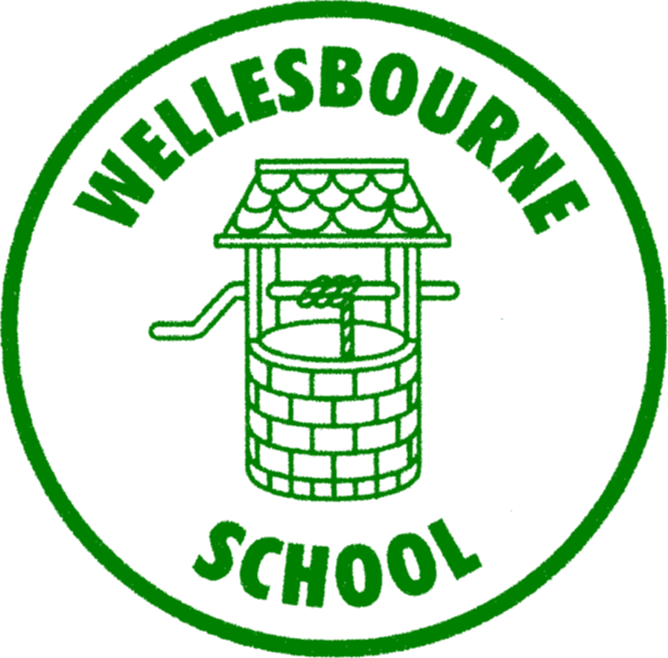
WELLESBOURNE PRIMARY
AND NURSERY SCHOOL
Living to Learn, Learning to Live
Promoting British Values Policy

SEPTEMBER 2016

Aims
This policy sets out the ways in which Wellesbourne Primary School encourages pupils to develop their understanding of the four key areas defined by DfE as British values, through the curriculum, extracurricular and other opportunities.

Ethos
At Wellesbourne Primary School we ensure that through our vision, values, relationships and teaching we promote tolerance and respect for all cultures, faiths and lifestyles.

The Governors also ensure that this ethos is reflected and implemented effectively through school policy and practice and that there are safeguarding policies in place to safeguard and promote pupils’ welfare.

We have a duty to prepare our pupils for life in modern Britain and to keep them safe. Everyone at Wellesbourne Primary School has the right to learn and work in safety. We do not tolerate bullying of any kind and will challenge derogatory language and behaviour towards others.

Background
As of November 2014 the government published guidance on promoting British values in schools to ensure young people leave school prepared for life in modern
Britain. Within this, all schools are required to ensure that the curriculum actively promotes these fundamental British values.

Definitions
Fundamental British values are defined by the DfE as:

Democracy: Respect for democracy and support for participation in the democratic process
The rule of law: Respect for the basis on which the law is made and applies in England
Individual liberty: Support and respect for the liberties of all within the law
Mutual respect and tolerance: Support for equality of opportunity for all and respect and tolerance of different faiths and religious and other beliefs.

Curriculum
We are committed to ensuring that our pupils are offered a broad and balanced curriculum that aims to prepare them for life in modern Britain. We encourage our pupils to be inquisitive learners who are open to new experiences and are accepting of others. Our values support the development of the whole child as a reflective learner within a safe respectful learning environment. Teaching the schools’ core values alongside the fundamental British values supports quality teaching and learning, whilst making a positive contribution to the development of a fair, just and civil society.

Through our balanced curriculum and SMSC we aim to actively promote principles that:
- Enable pupils to develop their self-knowledge, self-esteem and self-confidence
- Enable pupils to distinguish right from wrong and to respect the civil and criminal law of England
- Encourage pupils to accept responsibility for their behaviour, show initiative and understand how they can contribute positively to the lives of those living and working in the locality in which the school is situated, and to society more widely
- Enable pupils to acquire a broad general knowledge of and respect for public institutions and services in England
- Further tolerance and harmony between different cultural traditions by enabling pupils to acquire an appreciation of and respect for their own cultures
- Encourage respect for other people, paying particular regard to the protected characteristics set out in the Equality Act 2010
- Encourage respect for democracy and support for participation in the democratic process, including respect for the basis on which the law is made and applied in England.

Some examples of ways in which we actively promote British Values at Wellesbourne Primary School

Democracy:
- Formulate and agree a set of ‘class rules’ at the beginning of each school year.
- Elect class representatives to our school council.
- Have a school council who meet regularly and provide a ‘pupil voice’.
- Allow the children’s voice to be heard. We regularly ask for their views.
- Ask children to support the interviewing process for new staff.
- Discuss democracy within assemblies.
- Carry out debates in assembly to encourage free speech and allow children to listen to and consider others points of view

The Rule of Law:
- Have a clear, consistent behaviour policy (based upon positive rewards) which is consistently applied throughout the school.
- Elect playground buddies to help children to reflect on, and find solutions to problems
- Provide opportunities for children to reflect about positive and negative behaviour
- Provide an extensive Road Safety programme throughout the school.
- Have regular visits from our Police Community Support Officer.
- Address issues of law during whole-school assemblies as and when appropriate.
- Give considerable time to individual pupils who require additional opportunities to understand the importance of following rules.
- Encourage visits from external agencies to talk to the children in school.

Individual Liberty:
- Pupils are actively encouraged to make choices at our school, knowing that they are living within a safe and supportive environment.
- Pupils are encouraged to know, understand and exercise their rights and personal freedoms and are advised how to exercise these safely, for example through our e-Safety teaching.
- Pupils are given important roles in school, such as playground pals, peer mediators and young ambassadors.
- Children are encouraged to understand responsibility in school in terms of behaviour and attitude to learning.
- Justice and fairness are key principles within our school.
- Pupils are taught how to be safe and how to act safely. This is given an additional emphasis during anti-bullying week.

Mutual Respect:
- Respect and Responsibility are key values which permeate all aspects of school life at Wellesbourne Primary School. They determine the way in which we support and care for each other, for the community and for the environment.

At Wellesbourne Primary School children learn respect through;
- The promotion of positive relationships.
- The modelling of positive relationships by all adults working in school.
- The RE and SMSC curriculum which teaches that behaviour has an effect upon those around them and upon their own rights.
- All other aspects of the curriculum (as successfully working in groups requires respect for each other).
- The work of the school council
- The positive reward system developed to promote respect.
- Our celebration assemblies when all pupils show respect for the efforts of others.
- Giving responsibility to pupils (Y6 prefects, playground pals, e-safety warriors, ambassadors.)
- Participation in events organised to raise money for various charities.
- Learning to get along with their peers on educational residential visits.

Tolerance of Those of Different Faiths and Beliefs:
Tolerance is promoted in our school through:
- The stated aims and values of the school.
- The SMSC curriculum.
- The RE curriculum.
- The Modern Foreign Languages curriculum.
- Educational visits to places of religious worship.
- Class and whole school assemblies.
- Festival study and celebration
- Work on prejudice-based bullying during anti-bullying week.
- Using world events as opportunities to positively reinforce life and culture in other countries
- A non-negotiable approach towards the expression of views contrary to our agreed set of values.

Monitoring and Review
This policy will be monitored and reviewed by the Governors
Written September 2016

