Wellesbourne Primary and Nursery School Pupil Premium Spending Review
October 2020

The Pupil Premium Grant is allocated to schools at the beginning of each financial year. The allocation is decided by a fixed amount per child, when the family is entitled to free school meals. Schools are free to spend their Pupil Premium grant as they see fit. The Head Teacher has absolute discretion to decide, using all reasonable endeavours, how best the Pupil Premium be spent to benefit each child.
The Head Teacher will, so far as reasonable and practicable, consult with the leadership team, governing body, all staff and/or other interested parties, to assist her in making a well informed decision.
There is a higher percentage of children at Wellesbourne Primary and Nursery School allocated Pupil Premium than the national average.
The priorities for use of the pupil premium for 2019 – 2020 will address the barriers for learning within the following areas:

Raising attainment in Reading, Writing and Mathematics for those pupils eligible for pupil premium
Acquiring effective materials /resources, including human.
Improving attendance and punctuality
Enrichment

To diminish the difference in progress and attainment of all learners across all years for both PP and Not PP and to bring attainment and progress at least in line with that of national ‘other’ (pupil not eligible for PP)

SUMMARY
Due to unforeseen circumstances the data for the end of the summer term 2020 is unavailable.
For the purpose of this document progress data for the first two terms of the year 2019-2020 from two groups have been analysed, those entitled and those not entitled to Pupil Premium Funding.

Year 1 - % pupils making 4 steps progress over two terms
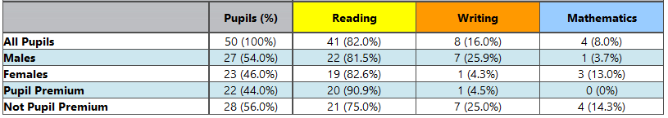

Year 2 – % Pupils making 4 steps progress over two terms
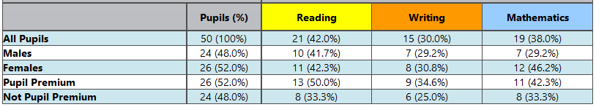

Year 3 – % Pupils making 4 steps progress over two terms
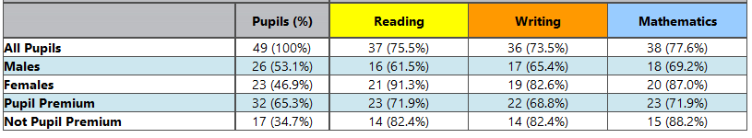

Year 4 – % Pupils making 4 steps progress over two terms
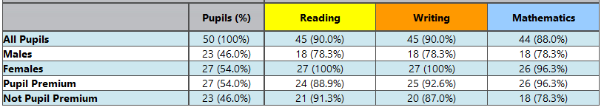

Year 5 – % Pupils making 4 steps progress over two terms
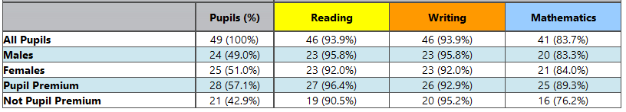

Year 6 – % Pupils making 4 steps progress over two terms
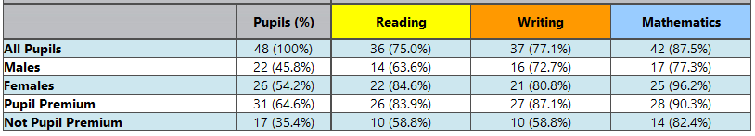

School in year progress is a mixed picture in many year groups those who are entitled to Pupil Premium funding are making better progress that their peers who are not, this does not always result in attainment being better as in some cases there is a lot of catching up to do. As a school we are pleased with the progress of our Pupil Premium children in all subjects, however with missing data for the summer term this data is not robust.
While the tracking of data is important in reviewing and evaluating pupil premium expenditure it is important to note that success in addressing some of the barriers for learning identified in the spending plan (Home Circumstances, Low levels of Parental Involvement, Low levels of Confidence/ Low Self Esteem, Low Aspirations, Limited Life Experiences, Emotional Needs) is not always easily identified in this data. Identification of this success is soft data this is evidenced in the case studies, on the web site and anecdotally with relevant members of staff.

