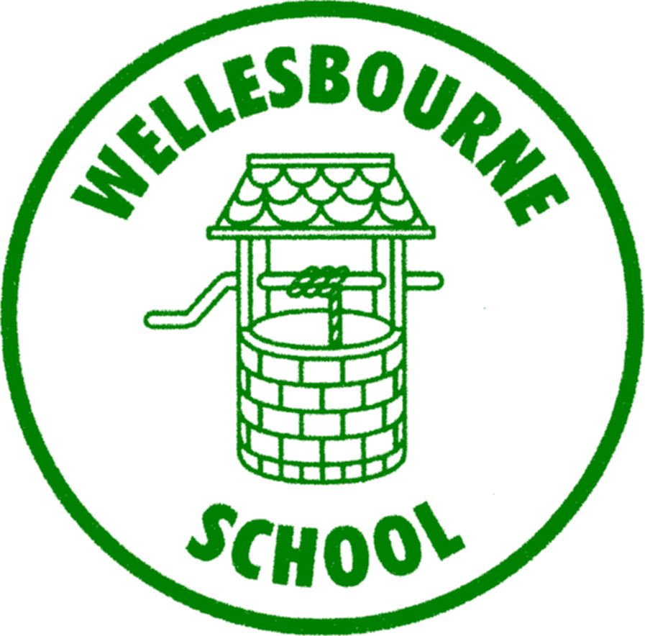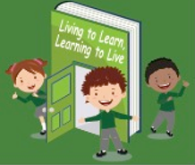
WELLESBOURNE PRIMARY
AND NURSERY SCHOOL
REACH for the stars

Safeguarding Policy
Children’s Version

The right to be healthy.
The right to be educated.
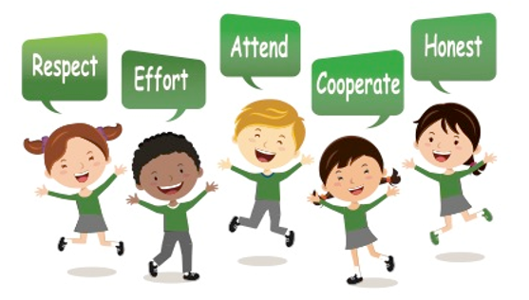
The right to be treated fairly.

The right to a childhood.
The right to be heard

Respect Effort Attend Cooperate Honest

What is this?
Your school has a Safeguarding Policy for staff, families and governors.
This ‘child friendly’ policy is designed for young people and this should be read as a guide to the main policy.
What is it for?
To help you decide what could be a ‘problem’ and where to get help and support.

Is someone bullying you?
You must tell someone at school so we can help you.

Examples of people you can tell are:
• Your Teacher
- Mrs Willshire
• Miss Moore
- Ms Mallon
- Mrs Ryan
• Your Teaching Assistant
• Your Dinner Lady

Do NOT keep it a Secret!
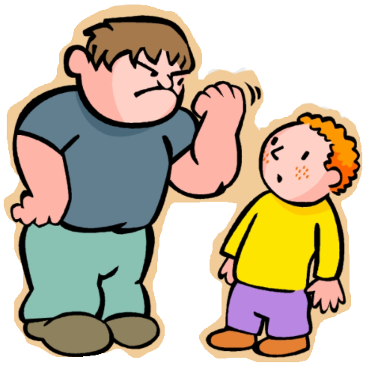
Saying funny things to you
Has someone said something to you or have you heard
something that you do not like or upsets you?
You must tell someone at the school so we can help you.

Examples of people you can tell are:
• Your Teacher
- Mrs Willshire
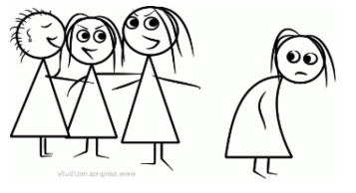
• Miss Moore
- Ms Mallon
- Mrs Ryan
• Your Teaching Assistant
• Your Dinner Lady
Do NOT keep it a Secret!
Touching you
Has someone touched you on a part of your body like your bottom, chest or anywhere else you do not like?
You must tell someone at school so we can help you.
Examples of people you can tell are:
• Your Teacher
- Mrs Willshire
• Miss Moore
- Ms Mallon
- Mrs Ryan
• Your Teaching Assistant
• Your Dinner Lady

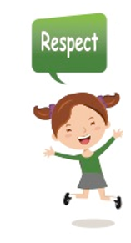
Trying to give you tablets, cigarettes, drugs or alcohol
Has someone asked you if you want a tablet or to smoke a cigarette, or have a drink of something and you do not know what it is?
Do not eat, drink or smoke what they are giving you.
You must tell someone at the school so we can help you.
Examples of people you can tell are:
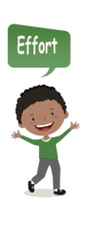
• Your Teacher
If you are unhappy – speak to someone at school.
- Mrs Willshire
• Miss Moore
- Ms Mallon
- Mrs Ryan
• Your Teaching Assistant
• Your Dinner Lady
Hitting, punching or smacking you
Has someone hit, punched or smacked you or hurt you in anyway?
You must tell someone at the school so we can help you.
Examples of people you can tell are:
• Your Teacher
If someone has hurt you in any way – you must tell someone at school.
Why not put a note in the worry box.
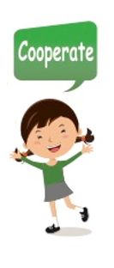
- Mrs Willshire
• Miss Moore
- Ms Mallon
- Mrs Ryan
• Your Teaching Assistant
• Your Dinner Lady
The four main areas of Child Protection concerns are:
1. Physical Abuse – hitting, smacking, shaking, throwing, burning, biting etc.
2. Sexual Abuse – be aware this doesn’t always mean actually touching a child.
It could be someone making you watch things to do with sex or encouraging you to act in an inappropriate way.
3. Neglect – this means things like not providing meals or warmth or clothing.
Or perhaps not taking you to the Doctors when you need to go. There may be lots of different reasons why a child is neglected and it is really important that we know so we can help.
4. Emotional Abuse – This means when someone upsets you or makes you feel bad. If someone in your family says horrible things to you and makes you feel sad and worthless.
the school Safeguarding Team:
Mrs Willshire, Miss Moore, Ms Mallon, Mrs Ryan or Miss O’Donnell

If you think you may have a problem that is similar to one of these then talk to

your teaching assistant or dinner lady.
your teacher

How does your school work to protect children?
There are lots of different ways, but one of the main ways is
making sure the staff here at your school know how to keep
you safe and also make sure you have someone to talk to if
you need to.

Your Head teacher is here to support young people and their families if there is a Child Protection concern.
Safeguarding and Child Protection mean the same thing and they mean that we look after children and keep them safe.
Talk to someone

What are the next steps?
Sometimes a member of staff at your school will need
to check things with your Head teacher and then if
they can deal with the issue themselves, they will.

There are times though when they may need to contact
some other agencies for support. This may
be Children’s Social Care (Social Workers) or Police.

There are lots of other agencies who support children
and their families as well.

Your Head teacher will talk to you and explain all of
this and you can always go and ask them questions
if you are unsure about anything.

