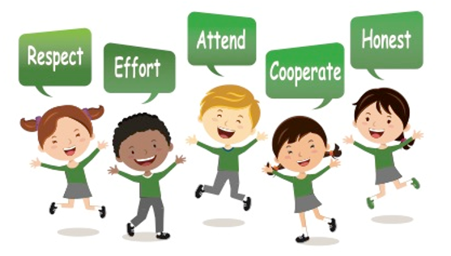

Progression of Skills in Geography

 | Understanding the World
Nursery | The World  Pupils will comment and ask questions about aspects of their familiar world, such as the place where they live or the natural world. To talk about some of the things they have observed, such as plants, animals, natural and found objects. Pupils will talk about why things happen and how things work. They will develop an understanding of growth, decay and changes over time. Pupils will show care and concern for living things and the environment.
Reception | The World  Pupils will look closely at similarities, differences, patterns and change.  Pupils will know about similarities and differences in relation to places, objects, materials and living things. They will talk about the features of their own immediate environment and how environments might vary from one another.  People and Communities  Pupils will talk about past and present events in their own lives and in the lives of family members. They will know about similarities and differences between themselves and others, and among families, communities and traditions
 | Geographical Enquiry | Place Knowledge | Human and Physical Geography | Geographical Skills and Fieldwork
Year 1 | Pupils will name and locate the four countries and capital cities of the United Kingdom. | Pupils will understand geographical similarities and differences through studying the human and physical geography of a small area of the United Kingdom. | Pupils will identify seasonal and daily weather patterns in the United Kingdom.  Pupils will use basic geographical vocabulary to refer to key physical features and human features.  Pupils will begin to locate hot and cold areas of the world in relation to the Equator and the North and South Poles. | Pupils will use world maps, atlases and globes to identify the United Kingdom and its countries.  Pupils will use simple fieldwork and observational skills to study geography of their school and its grounds and the key human and physical features of its surrounding environment.
Year 2 | Pupils will identify characteristics of four countries and capital cities of the United Kingdom and its surrounding seas.  Pupils will name and locate the world’s seven continents and five oceans. | Pupils will understand geographical similarities and differences through studying the human and physical geography of a small area of the United Kingdom, and a small area of a contrasting non-European country. | Pupils will locate hot and cold areas of the world in relation to the Equator and the North and South Poles.  Pupils will use more basic geographical vocabulary to refer to key features and human features. | Pupils will use world maps, atlases and globes to identify the UK, its countries and counties.  Pupils will use simple compass directions.  Pupils will use aerial photographs and plans to recognise landmarks to devise a simple map.  Pupils will use simple fieldwork and observational skills to study the geography of key human and physical features of the schools surrounding environment.
Year 3 | Pupils will know about the local area.  Pupils will describe simply where places are beyond the local area. | Pupils will describe what gives the local area character and simply describe what other places are like beyond this area. | Pupils will observe and describe physical features of the local area and other places.  Pupils will begin to compare these features to another place beyond the local area.  Pupils will begin to understand how people effect the environment. | Pupils will use maps, atlases, globes and digital/computer mapping (Google Earth) to locate countries and describe features studied.  Pupils will learn eight points of a compass, 2 figure grid reference, some basic symbols and key (including the use of basic ordinance survey maps) to build their knowledge of the United Kingdom and the wider world.  Pupils will use fieldwork to observe and record the human and physical features in the local area using a range of methods.
Year 4 | Pupils will know about the local area and begin to appreciate the importance of wider geographical location in understanding places.  Pupils will begin to describe and compare features of different locations and offer explanations for the locations of some of those features. | Pupils will be aware that different places may have both similar and different characteristics | Pupils will begin to describe physical and human features and begin to offer reasons for observations and opinions about places and environments.  Pupils will recognise how people try to improve and keep environments | Pupils will use maps, atlases, globes and digital/computer mapping (Google Earth) to locate countries and describe features studied.  Pupils will learn the eight points of a compass, four-figure grid references.  Pupils will use fieldwork to observe, measure and record the human and physical features in the local area using a range of methods, including sketch maps, plans and graphs, and digital technologies.
Year 5 | Pupils will know about the features of a variety of places around the world from local to global | Pupils will understand more about the links between different places and that some places depend on each other | Pupils will begin to explain geographical patterns and a range of physical and human processes.  Pupils will recognise that these interact to affect the lives and activities of people living there.  Pupils will understand how people can both improve and damage the environment. | Pupils will use maps, atlases, globes and digital/computer mapping (Google Earth) to locate countries and describe features studied.  Pupils will learn the eight points of a compass, four-figure grid references, symbols and keys (including on an Ordinance Survey map) to build their knowledge of the United Kingdom in the past and present.  Pupils will use fieldwork to observe, measure and record the human and physical features in the local area using a range of methods, including sketch maps, plans and graphs, and digital technologies.
Year 6 | Pupils will know about the features of a variety of places around the world from local to global and in different parts of the world.  Pupils will identify the position and significance of latitude, longitude, Equator, Northern hemisphere, Southern Hemisphere, the Tropics of Cancer and Capricorn, Artic and Antarctic Circle, the Prime/Greenwich Meridian and time zones (including day and night). | Pupils will understand more about the links between different places and that make places depend on each other. | Pupils will describe and explain a range of physical and human processes and recognise that these processes interact to produce distinctive characteristics of places.  Pupils will describe ways in which physical and human processes operating at different scales create geographical patterns and lead to changes in places. | Pupils will use maps, atlases, globes and digital computer mapping (Google earth) to locate countries and describe features studied.  Pupils will extend to 6 figure grid references with teaching of latitude and longitude in depth.  Pupils will expand map skills to include non-UK countries  Pupils will use fieldwork to observe, measure and record the human and physical features in the local area using a range of methods, including sketch maps, plans and graphs, and digital techniques.

