Pupil premium strategy statement – Wellesbourne Primary and Nursery School 2025-2026

This statement details our school’s use of pupil premium (and recovery premium) funding to help improve the attainment of our disadvantaged pupils.
It outlines our pupil premium strategy, how we intend to spend the funding in this academic year and the outcomes for disadvantaged pupils last academic year.

School overview
Detail | Data
Number of pupils in school | 375 (Including Nursery)
Proportion (%) of pupil premium eligible pupils | 57.5% (207)
Academic year/years that our current pupil premium strategy plan covers (3 year plans are recommended) | 2023/24-2026/27
Date this statement was published | November 2025
Date on which it will be reviewed | November 2026
Statement authorised by | Carl Gilbertson
Pupil premium lead | Nicola Ryan
Governor / Trustee lead | Carl Gilbertson

Funding overview
Detail | Amount
Pupil premium funding allocation this academic year | £311,971
Recovery premium funding allocation this academic year | £0
Pupil premium (and recovery premium*) funding carried forward from previous years (enter £0 if not applicable) | £0
Total budget for this academic year | £311,971

Part A: Pupil premium strategy plan

Statement of intent
Our intention is that all pupils, irrespective of their background or the challenges they face, make good progress and achieve high attainment across all subject areas. The focus of our pupil premium strategy is to support disadvantaged pupils to achieve that goal, including good progress for those who are already high attainers.
We will consider the challenges faced by vulnerable pupils, such as those who have a social worker or are young carers. The activity we have outlined in this statement is also intended to support their needs, regardless of whether they are disadvantaged or not.
Quality first teaching is at the heart of our approach, with a focus on areas in which disadvantaged pupils require the most support. This is proven to have the greatest impact on closing the disadvantage attainment gap and at the same time will benefit the non-disadvantaged pupils in our school. Implicit in the intended outcomes detailed below, is the intention that non-disadvantaged pupils’ attainment will be sustained and improved alongside progress for their disadvantaged peers.
We have used the EEF Pupil Premium Guide April 2022 to support our strategy for spending Pupil Premium funding and have adopted a tiered approach to spending:
1. Quality First Teaching - Ensuring an effective, skilled teacher is in front of every class.
2. Targeted academic support – A clear robust process that allows teaching staff to identify children who are behind or who may be making less than expected progress. Evidence consistently shows the positive impact that targeted academic support can have, including on those who are not making good progress. Considering how classroom teachers and teaching assistants can provide targeted academic support, including how to link structured one-to-one or small group intervention to classroom teaching, is likely to be a key component of an effective Pupil Premium strategy. The EEF have evaluated the impact of a range of strategies and schools are encouraged to make use of these resources.
3. Wider strategies - Wider strategies relate to the most significant non-academic barriers to success in school, including attendance, behaviour and social and emotional support. While many barriers may be common between schools, it is also likely that the specific features of the community each school serves will affect spending in this category. The purpose of this strategy is to outline how the Pupil Premium Grant will be allocated to support pupils during the period between September 2023 and July 2026, with specific adaptations made for this academic year, 2025-26. Our determined and committed leadership team strives to ensure that Pupil Premium funding and provision positively impacts achievement, attendance and pastoral care. Termly data analysis and pupil progress meetings ensure that those entitled to pupil premium funding are monitored and compared to other pupils in school to ensure the correct strategies and provision are in place.

Challenges
This details the key challenges to achievement that we have identified among our disadvantaged pupils.
Challenge number | Detail of challenge
1 | Low level starting points in EYFS particularly around fine motor skills/ oracy and word reading
2 | Lack of cultural capital experiences
3 | Lower income families can often find it more difficult to provide uniforms, PE kits, pay contributions to school trips/ educational visits that enhance children’s education
4 | Increased numbers of pupils with complex needs, including speech and language, social communication, poor working memory, attention difficulties, motor skills, ASD & social emotional and mental health
5 | Low attendance and high number of Persistent Absentees
6 | Lower levels of parental partnership (parental engagement, support for home learning, regard for education)

Intended outcomes
This explains the outcomes we are aiming for by the end of our current strategy plan, and how we will measure whether they have been achieved.
Intended outcome | Success criteria
Pupils with low attendance/ punctuality issues are supported and challenged, children entitled to Pupil Premium funding will have attendance in line with national average or above (target of 95% minimum)  Gap between PP and non-PP children will diminish. Currently 92.04% PP and 96.14% Non-PP. | - Attendance officer appointed  - EWO to support families  - Regular Attendance Team meetings to look at specific groups and offer solutions to tackle poor attendance  - The gap between the attendance of PP and non-PP will diminish.  - Good attendance will have a positive impact on attainment.
Increase the percentage of children achieving a ‘Good Level of Development’ at the end EYFS. 2022- 39% 2023- 65% 2024- 63%  Low level starting points, particularly in CLLD, will be identified up on entry and children will be supported to make rapid progress and diminish the difference between disadvantaged and non disadvantaged pupils. | - Children identified from Reception Baseline Assessments  - Tracking in place, Phonics, Physical Assessments, Observations.  - Regular interventions in place and having a positive impact upon children's attainment
Increase the percentage of disadvantaged pupils meeting the expected standard in reading, writing and mathematics across KS1. (Internal data) | - Disadvantaged pupils identified in Pupil Progress meetings.  - Weekly intervention sessions for KS1 pupils with 1:1 and small group tuition.  - Teachers using gap analysis from internal assessments to inform future planning.  - Disadvantaged combined attainment score to be over 50% (previously 38%).
Available support for families who need it. Children will have equal access to uniforms and trips, access to extra-curricular activities will not be inhibiting children from lower income families will have uniforms, PE kits and attend school trips/ educational visits. | - Mentor support for families  - Access to wider agencies such as Cobalt and Clubmoor via pastoral team  - Attendance officer to support families  - Links developed with local uniform stockists
To continue to be at national or above for phonics screening check Y1 (80% 2025) | - Robust assessment  - Phonics training in house  - Interventions daily for children not ‘keeping up’  - Y1 phonics data to be in line or above national average for 2026
An increase in attendance and a decrease of the number of Persistent Absentees. | - Attendance team intervention  - EWO support  - Attendance initiatives
A strong parental partnership (parental engagement, support for home learning) | - Parent workshops attended  - Stay, Play and Learn Sessions support families working with their children  - SEND Coffee mornings

Activity in this academic year
This details how we intend to spend our pupil premium (and recovery premium) funding this academic year 2025-2026 to address the challenges listed above

Teaching (for example, CPD, recruitment and retention)
Budgeted cost: £ 8,000
Activity | Evidence that supports this approach | Challenge number(s) addressed
CPD across EYFS setting ELKLAN | Supporting continuous and sustained professional development is crucial to developing teacher practice. The content of professional development should be based on the best available evidence and should balance the need to build knowledge, motivate teachers, develop specific techniques, and embed new approaches. | 4
Phonics Lead to offer drop-in sessions of training for all staff | Professional development to support the implementation of validated systematic synthetic phonics programme | 1 & 3
Recruitment and retention of teaching staff - providing cover time to undertake professional development National Professional Qualifications (NPQs) X2 | Staff member undertaking Primary NPQLT Training  EYFS Staff & Pastoral Team Member to complete Elklan Speech and Language training.  NPQH – Deputy Head  Managing workload and offering effective professional development are key to retaining great teachers, which, in turn, is crucial to maintaining a high standard of teaching and learning. | 1, 2 & 6
Outdoor adventurous activity, dance and netball Training for Sports Apprentice | As above | 2
Oracy in Mathematics training for lead  Greater depth maths training for all teaching staff February 2026 – Melanie Pitt | Supporting continuous and sustained professional development is crucial to developing teacher practice. The content of professional development should be based on the best available evidence and should balance the need to build knowledge, motivate teachers, develop specific techniques, and embed new approaches. | 1
Leading English Literacy Counts training for Reading Lead | As above | 1
EAL Training | Twilight session with a focus on assessing children with EAL
Strong Foundations Training | Lisa Littler training around strong foundations for Early Years & SLT  School Improvement Training for Nursery, Reception and Year 1 Staff based upon early writing and developing strong foundational skills. | 1

Targeted academic support
Budgeted cost: £ 267,000
Activity | Evidence that supports this approach | Challenge number(s) addressed
2 X Full time SEND and Pastoral Support Worker.  Work with identified children on a 1:1 needs basis. | One to one or small group work support for our most vulnerable children supports their academic progress and their emotional wellbeing.  EEF Menu of Approaches Page 1 | 4
One to one, small group or peer academic tuition teacher led | Small group tuition is defined as one teacher or professional educator working with two to five pupils together in a group. This arrangement enables the teacher to focus exclusively on a small number of learners, usually in a separate classroom or working area. Intensive tuition in small groups is often provided to support lower attaining learners or those who are falling behind, but it can also be used as a more general strategy to ensure effective progress, or to teach challenging topics or skills. Overall, evidence shows that small group tuition is effective and, as a rule of thumb, the smaller the group the better. Tuition in groups of two has a slightly higher impact than in groups of three, but a slightly lower impact than one to one tuition. Some studies suggest that greater feedback from the teacher, more sustained engagement in smaller groups, or work which is more closely matched to learners’ needs explains this impact. Once group size increases above six or seven there is a noticeable reduction in effectiveness.  EEF Menu of Approaches Page 1 | 1
Time allocated for teaching assistants to provide 1:1 and small group intervention | As above | 1

Wider strategies (for example, related to attendance, behaviour, wellbeing)
Budgeted cost: £ 46,000
Activity | Evidence that supports this approach | Challenge number(s) addressed
Wellbeing Team – provide strategies that support children's mental health and wellbeing. Activities such as Yoga Bears, Zones of Regulation, Friendship Groups, Chatterbox. | Social and emotional skills support effective learning and are linked to positive outcomes later in life. Schools may consider whole-class approaches as well as targeted interventions, monitoring the impact of these choices carefully  EEF Menu of Approaches P3 | 2 & 5
Wellbeing Walks X2 Per week for identified groups KS1 and KS2 | As above | 4 & 5
School Education Welfare Officer and Attendance Lead | Poor attendance at school is linked to poor academic attainment across all stages. Some parental communication approaches and targeted parental engagement interventions show promise in supporting pupil attendance.  EEF Menu of Approaches P3 | 5
Children’s University Subscription | Extracurricular activities are an important part of education in their own right. These approaches may increase engagement in learning, but it is important to consider how increased engagement will be translated into improved outcomes.  EEF research finds Physical activity has important benefits in terms of health, wellbeing and physical development.  EEF Menu of Approaches P3 | 2
Full of Beans Playleaders | As above  https://educationendowmentfoundation.org.uk/education-evidence/teaching-learning-toolkit/physical-activity | 2
Educational visits linked to the curriculum | Arts participation is defined as involvement in artistic and creative activities, such as dance, drama, music, painting, or sculpture. It can occur either as part of the curriculum or as extra-curricular activity. Arts-based approaches may be used in other areas of the curriculum, such as the use of drama to develop engagement and oral language before a writing task.  https://educationendowmentfoundation.org.uk/education-evidence/teaching-learning-toolkit/arts-participation | 2
Breakfast and Afterschool Clubs  Including Chess, Debate Club, Minecraft, Football, Dodgeball, Yoga Bears, Cricket, Cross Country, Cookery, Girls Football. | There is some evidence that providing free, universal, before-school breakfast clubs can benefit pupils by preparing them for learning or supporting behaviour and school attendance.  EEF Menu of Approaches P3. | 2

Total budgeted cost: £ 321,000
£311,971 provided from Pupil Premium
£9,029 from school budget

Part B: Review of the previous academic year

Outcomes for disadvantaged pupils
We have made significant progress towards achieving the intended outcomes set out in our 2024/25 strategy plan. We successfully embedded Essential Letters and Sounds Phonics scheme and made significant improvements on the number of children achieving the pass mark than in 2023/24. Strong subject leadership, high-quality phonics teaching and a relentless focus on providing the best support for our pupils so that they learn to read proficiently, has led to improved outcomes. This and working alongside practitioners from Childer Thorton Hub has really improved how we deliver early reading.
The school has a strong commitment to supporting the CPD of all staff. A multitude of training and support has been put in place to enhance the skills of our biggest resource and, in return, led to improvements in the quality of first teaching. Considerable time and resource has been spent improving staff knowledge and understanding of children with SEND, a growing number in our setting. The quality of support provided by our Inclusion team has been identified as a strength during a recent, commissioned review of our SEND provision.
Outcomes for disadvantaged pupils in the 2025 statutory assessments
We have analysed the performance of our school’s disadvantaged pupils at the end of the 2024/25 academic year using national performance data, phonics check results and our own internal tracking system and assessments. This review captures the attainment of pupils in Reception, Year 1, Year 4 and Year 6 - those areas where a statutory testing and data submission is required.
Reception GLD 2025
63.4% of our Reception cohort achieved GLD at the end of 2024. 65% of children who are entitled to Pupil Premium funding achieved this mark, this is in line with those who are not entitled to the funding.
Year 1 Phonics Screening Check in 2025
Outcomes in the Year 1 PSC continue to grow from strength to strength and we continue to close the gap to national. Our outcomes in 2025 were higher than the national average, this is due to the rigorous teaching and the successful implementation of our Systematic Synthetic Phonics Programme, Essential Letters and Sounds. Strong teaching as a result of strong subject leadership has also had a positive impact. Overall Year 1 Phonics attainment was 80%, in line with national. 75% of those entitled to Pupil Premium Funding achieved the pass mark, this is higher than the national 67%.

Year 4 Multiplications Check 2025
75% of our Year 4 cohort scored full marks in the MTC (Multiplication Tables Check), 79% of the those entitled to Pupil Premium funding passed the Y4 MTC. Those entitled to the funding did significantly better than those who are not.
Year 6 End of Key stage Data 2025
Percentages of children achieving expected and above
 | READING | WRITING | MATHEMATICS | RWM+
PP FUNDING | 82% | 76% | 76% | 71%
NON PP FUNDING | 81% | 82% | 89% | 76%

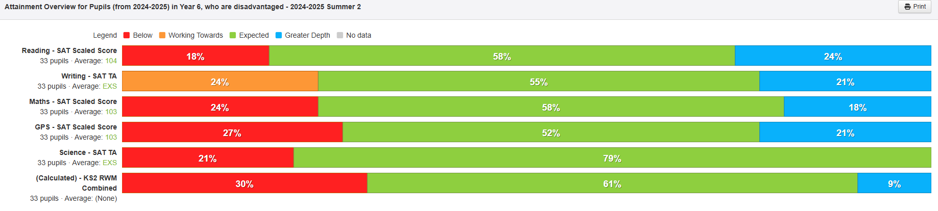
Whole School Data 2024-2025 (disadvantaged)
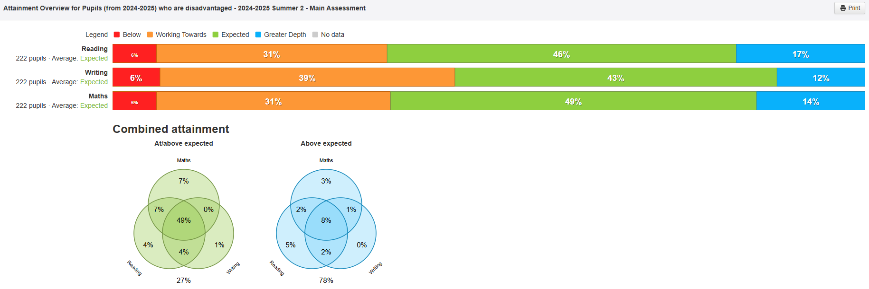
Whole School Progress Data 2024-2025 (disadvantaged)
Below are progress measures for children entitled to Pupil Premium funding, largely children are making expected or above expected progress for reading, writing and mathematics.
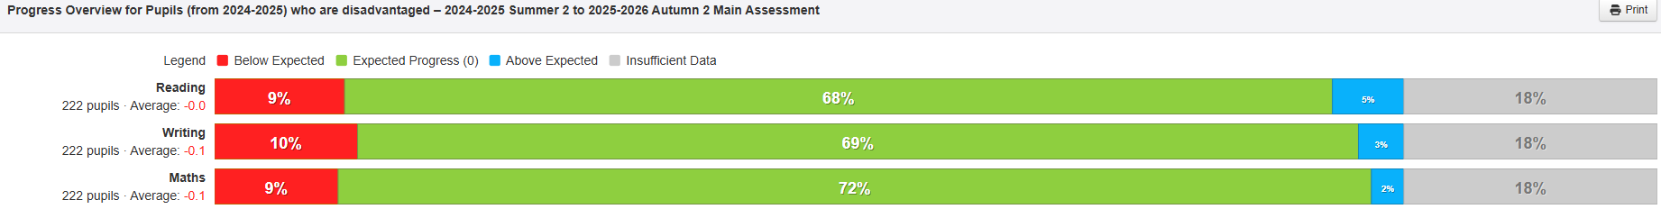

Externally provided programmes
Please include the names of any non-DfE programmes that you used your pupil premium (or recovery premium) to fund in the previous academic year.
Programme | Provider
ELS | CPOMS
WELCOM | NELLI
TIMESTABLES ROCKSTARS | LEXIA
YOGA BEARS | PROVISION MAP
READ TO WRITE | WHITE ROSE MATHS
PSHE ASSOCIATION

