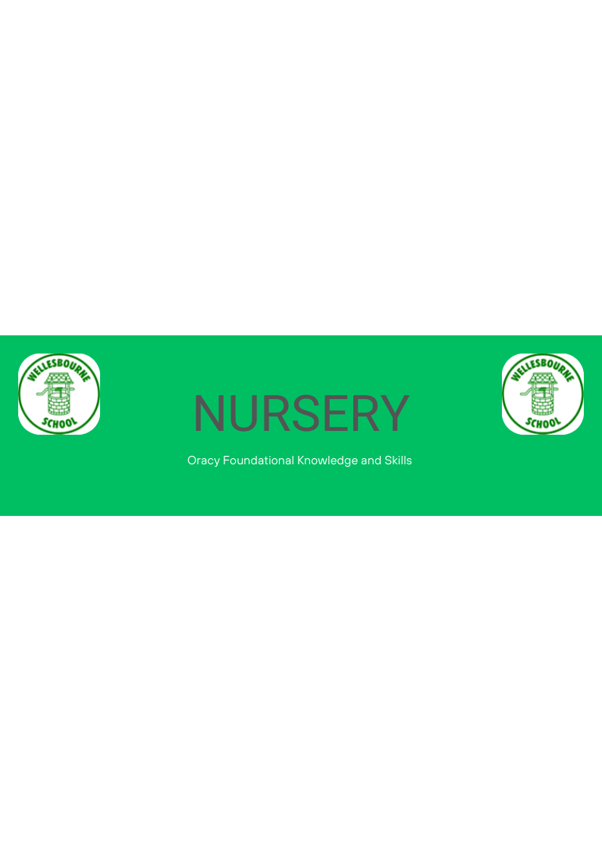
EYFS Statutory Educational Programme: The development of children’s spoken language underpins all seven areas of learning and development. Children’s back‑and‑forth interactions from an early age form the foundations for language and cognitive development. The number and quality of the conversations they have with adults and peers throughout the day in a language-rich environment is crucial. By commenting on what children are interested in or doing, and echoing back what they say with new vocabulary added, practitioners will build children’s language effectively.
 | Autumn | Spring | Summer
Physical | ~Turn body towards the speaker for an appropriate amount of time  ~To speak to be heard clearly by others |  | ~To speak to be heard clearly by others
Linguistic | ~To use talk in play to practise new vocabulary | ~To use talk in play to practise new vocabulary | ~To join phrases with words such as ‘if’, ‘because’, ‘could’, ‘but’
Cognitive |  | ~To begin to understand how and why questions | ~To use ‘and’ to link their ideas  ~To describe events currently happening and what might happen next.
Social and Emotional | ~To listen to others | ~To take turns to speak with the support of an adult

