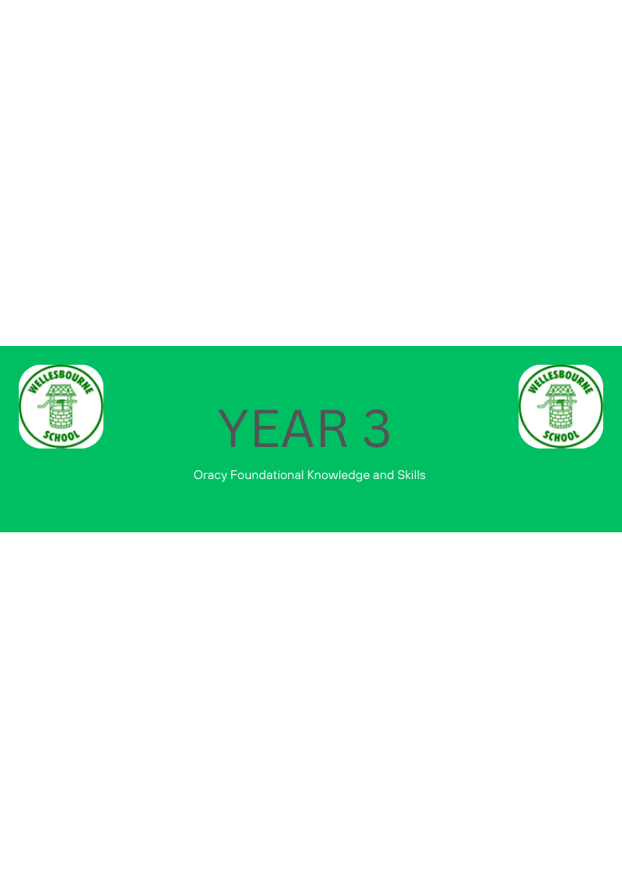
Keynote from National Curriculum for Year 3 Teachers:
•In Years 3 and 4, pupils should become more familiar with and confident in using language in a greater variety of situations, for a variety of audiences and purposes, including through drama, formal presentations and debate.
 | Autumn | Spring | Summer
Physical |  | ~Consider position and posture when addressing an audience | ~Select gestures that support the delivery of ideas e.g. gesturing towards someone if referencing their ideas.  ~Vary tone of voice in order to convey meaning e.g. speaking authoritatively during an expert talk.
Linguistic | ~Be able to use specialist language to describe own and others talk  ~Use specialist vocabulary e.g. speak like a scientist | ~ Make precise language choices e.g. instead of using ‘nice’ to describe a person they could say ‘thoughtful’
Cognitive |  | ~Offer opinions that aren’t their own taking on the role of....  ~Begin to reflect on discussions and their own oracy skills and identify areas of strength and areas to improve
Social and Emotional | ~Speak with confidence in front of an audience | ~Plans talk to suit the listener  ~Adapt the content of their speech for a specific audience | ~Engages in discussions/debates; maintains a role

