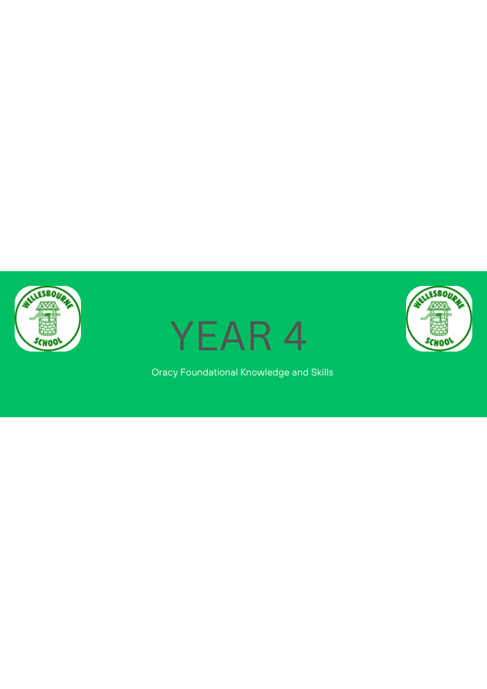
Keynote from National Curriculum for Year 4 Teachers:
•In Years 3 and 4, pupils should become more familiar with and confident in using language in a greater variety of situations, for a variety of audiences and purposes, including through drama, formal presentations and debate.
 | Autumn | Spring | Summer
Physical | ~Uses an increasing range of vocabulary mostly appropriately in different contexts | ~Speaks audibly and fluently in a range of contexts, using some features of standard English e.g. Uses a quieter voice in small group situations, louder voice for class assembly -Uses standard English when speaking in sentences | Computing – voice recording project
Linguistic | ~Carefully consider thoughts and phrasing they use to express their ideas and how this supports the purpose of the talk. e.g. to persuade or entertain
Cognitive |  | ~Plans their talk, taking account of audience and purpose e.g. explain and develops ideas across curriculum subjects, presentations  ~Explains a clearly sequenced process, using appropriate language
Social and Emotional | ~Discusses and debates issues, making their opinions on topics clear and asking for specific additional information, when needed | ~Discusses and debates issues, making their opinions on topics clear and asking for specific additional information, when needed e.g. -participates in drama, improvisation and role play activities, showing an understanding of character by choice of vocabulary to indicate feelings and emotions | ~Adapts language, tone and style to maintain interest

