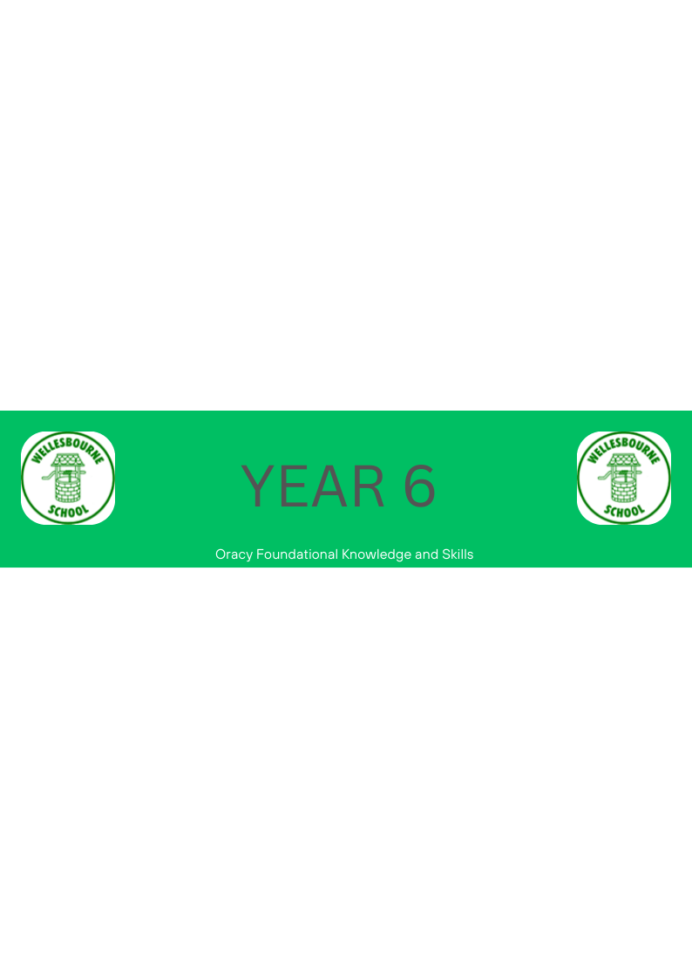
Keynote from National Curriculum for Year 6 Teachers:
•During Years 5 and 6, teachers should continue to emphasise pupils’ enjoyment and understanding of language, especially vocabulary, to support their reading and writing.
 | Autumn | Spring | Summer
Physical | ~Demonstrates attentive and sustained listening by justifying ideas or expanding on the ideas of a number of speakers e.g. nodding, facial expression
Linguistic | ~Use and innovate an increasingly sophisticated range of sentence stems with fluency and accuracy e.g. I have a different idea. I think… I have the same opinion as … I would like to go back to… and add… | ~Communicates detailed information clearly, using precise vocabulary | ~Uses adventurous and ambitious vocabulary in speech, which is always appropriate to the topic, audience and purpose
Cognitive |  | ~Maintains attention and participates actively in collaborative conversations, staying on topic and initiating and responding to comments with confidence | ~Reflect on own and others’ oracy skills and identify how to improve
Social and Emotional |  |  | ~Deliberately shapes talk for the listener, with variation in vocabulary and / or formality, for clarity and effect e.g. manipulates vocabulary and sentence structure to achieve formality -Adopts a formal or informal tone as appropriate to the situation

